 

**CAPSTONE PROJECT REPORT**

**PROJECT TITLE**

DISASTER RELIEF PLATFORM

**REPORT SUBMITTED BY:**

L.VARSHINI (192372045)

GIRIJA B (192311044)

**COURSE CODE**: CSA1086

**COURSE NAME:** Software Engineering for programming

**ABSTRACT:**

The Crowdsourced Disaster Relief Platform is a web-based solution to connect disaster victims with volunteers and donors. It provides three core features:

1. **Current Natural Disasters**: Displays ongoing disaster updates.
2. **Registered Volunteers**: Lists volunteers with skills and locations.
3. **Manage Requests**: Enables handling of help requests efficiently.

Developed using **HTML, CSS, and JavaScript**, the platform uses localStorage for lightweight data management and follows the **Scrum methodology** for iterative, user-focused development.

**INTRODUCTION:**

Disasters, both natural and man-made, often lead to significant destruction and loss, leaving victims in urgent need of assistance. The lack of a structured and centralized system for connecting disaster victims with volunteers and donors often delays relief efforts, exacerbating the situation.

**Background:**

Natural disasters such as floods, earthquakes, and hurricanes frequently affect communities worldwide, requiring immediate aid in terms of food, shelter, and medical supplies. However, relief operations are often hampered by fragmented communication and inefficient resource allocation.

**Objectives:**

The main objectives of the Crowdsourced Disaster Relief Platform are:

1. To create a centralized platform for victims to request assistance and for volunteers to register their availability.
2. To provide real-time information about ongoing disasters for better situational awareness.
3. To streamline the management of requests and ensure timely allocation of resources.
4. To foster collaboration between communities, volunteers, and donors for efficient disaster response.

**Methodology:**

The development of the Crowdsourced Disaster Relief Platform follows the **Scrum methodology**, an agile approach that emphasizes iterative development and continuous user feedback. This ensures the platform meets the needs of end-users effectively while allowing flexibility for improvements during the development cycle. The methodology is divided into the following phases:

**Requirements Gathering**

* Conducted brainstorming sessions to identify the core features of the platform: disaster updates, volunteer registration, and request management.
* Gathered feedback from potential users, such as volunteers, donors, and victims, to prioritize functionalities.
* Defined technical requirements, including the use of **HTML**, **CSS**, and **JavaScript** for implementation, along with **localStorage** for lightweight data management.

**System Design**

* Created wireframes and prototypes to visualize the user interface and layout of the platform.
* Designed data storage structures to organize volunteer and request information effectively in **localStorage**.
* Planned a modular architecture to separate disaster updates, volunteer management, and request handling functionalities.

**Code:**

**index.html:**

<!DOCTYPE html>

<html lang="en">

<head>

    <meta charset="UTF-8">

    <meta name="viewport" content="width=device-width, initial-scale=1.0">

    <title>Disaster Relief Platform</title>

    <link rel="stylesheet" href="style.css">

</head>

<body>

    <header>

        <h1>Disaster Relief Platform</h1>

    </header>

    <main>

        <section id="navigation">

            <h2>Navigate</h2>

            <ul>

                <li><a href="disasters.html">Current Natural Disasters</a></li>

                <li><a href="volunteers.html">Registered Volunteers</a></li>

                <li><a href="requests.html">Manage Requests</a></li>

            </ul>

        </section>

        <section id="forms">

            <h2>Register or Request Help</h2>

            <!-- Volunteer Form -->

            <div>

                <form id="volunteer-form">

                    <h3>Volunteer Registration</h3>

                    <input type="text" id="volunteer-name" placeholder="Your Name" required>

                    <input type="text" id="volunteer-location" placeholder="Your Location" required>

                    <input type="text" id="volunteer-skills" placeholder="Your Skills" required>

                    <button type="submit">Register</button>

                </form>

            </div>

            <!-- Help Request Form -->

            <div>

                <form id="request-form">

                    <h3>Request Help</h3>

                    <input type="text" id="name" placeholder="Your Name" required>

                    <input type="text" id="location" placeholder="Your Location" required>

                    <textarea id="help-needed" placeholder="What Help Do You Need?" required></textarea>

                    <button type="submit">Submit</button>

                </form>

            </div>

        </section>

    </main>

    <footer>

        <p>&copy; 2024 Disaster Relief Platform. All rights reserved.</p>

    </footer>

    <script src="script.js"></script>

</body>

</html>

**disasters.html:**

<!DOCTYPE html>

<html lang="en">

<head>

    <meta charset="UTF-8">

    <meta name="viewport" content="width=device-width, initial-scale=1.0">

    <title>Current Natural Disasters</title>

    <link rel="stylesheet" href="style.css">

</head>

<body>

    <header>

        <h1>Current Natural Disasters</h1>

    </header>

    <main>

        <section id="disaster-list">

            <!-- Disasters will be loaded dynamically -->

        </section>

        <a href="index.html" class="button">Back to Home</a>

    </main>

    <footer>

        <p>&copy; 2024 Disaster Relief Platform. All rights reserved.</p>

    </footer>

    <script src="disasters.js"></script>

</body>

</html>

**requests.html:**

<!DOCTYPE html>

<html lang="en">

<head>

    <meta charset="UTF-8">

    <meta name="viewport" content="width=device-width, initial-scale=1.0">

    <title>Manage Requests</title>

    <link rel="stylesheet" href="style.css">

</head>

<body>

    <header>

        <h1>Manage Requests</h1>

    </header>

    <main>

        <section id="request-list">

            <!-- Requests will be loaded dynamically -->

        </section>

        <a href="index.html" class="button">Back to Home</a>

    </main>

    <footer>

        <p>&copy; 2024 Disaster Relief Platform. All rights reserved.</p>

    </footer>

    <script src="requests.js"></script>

</body>

</html>

**volunteers.html:**

<!DOCTYPE html>

<html lang="en">

<head>

    <meta charset="UTF-8">

    <meta name="viewport" content="width=device-width, initial-scale=1.0">

    <title>Registered Volunteers</title>

    <link rel="stylesheet" href="style.css">

</head>

<body>

    <header>

        <h1>Registered Volunteers</h1>

    </header>

    <main>

        <section id="volunteer-list">

            <!-- Volunteers will be loaded dynamically -->

        </section>

        <a href="index.html" class="button">Back to Home</a>

    </main>

    <footer>

        <p>&copy; 2024 Disaster Relief Platform. All rights reserved.</p>

    </footer>

    <script src="volunteers.js"></script>

</body>

</html>

**volunteers.js:**

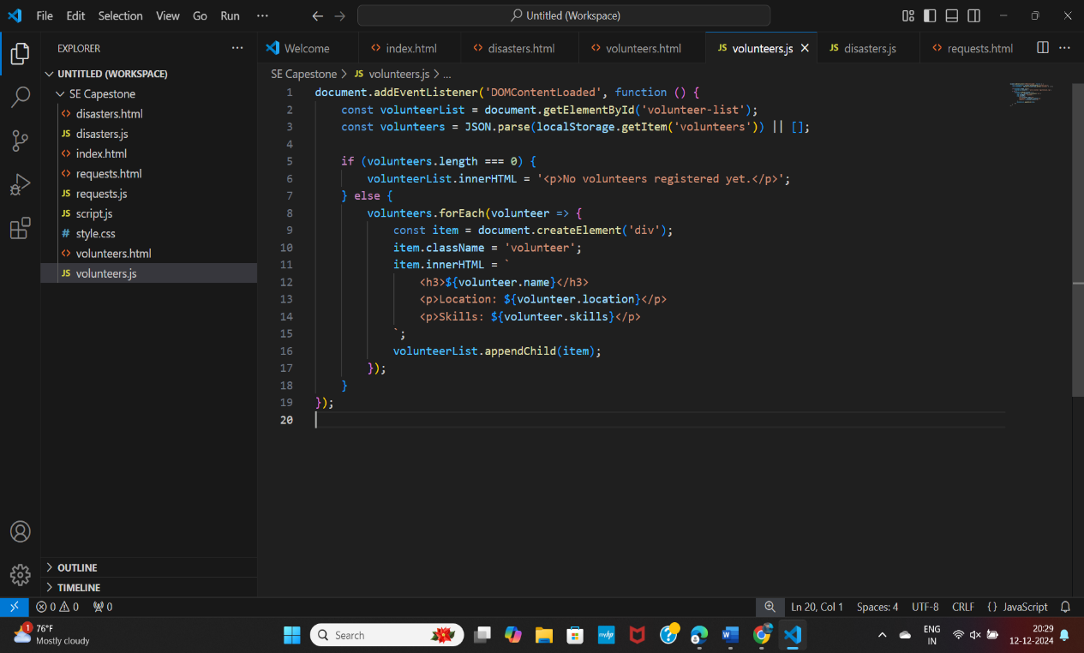

**disasters.js:**

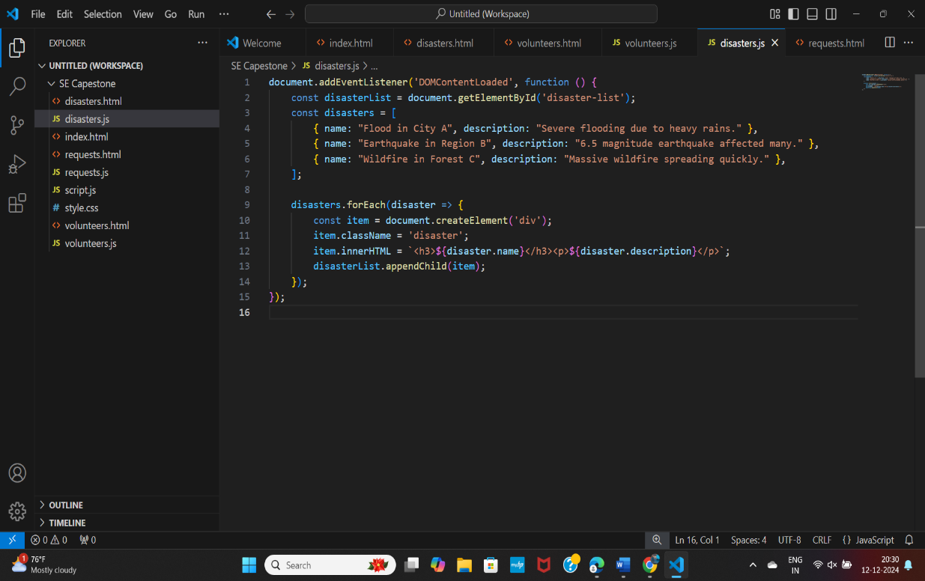

**requests.js:**

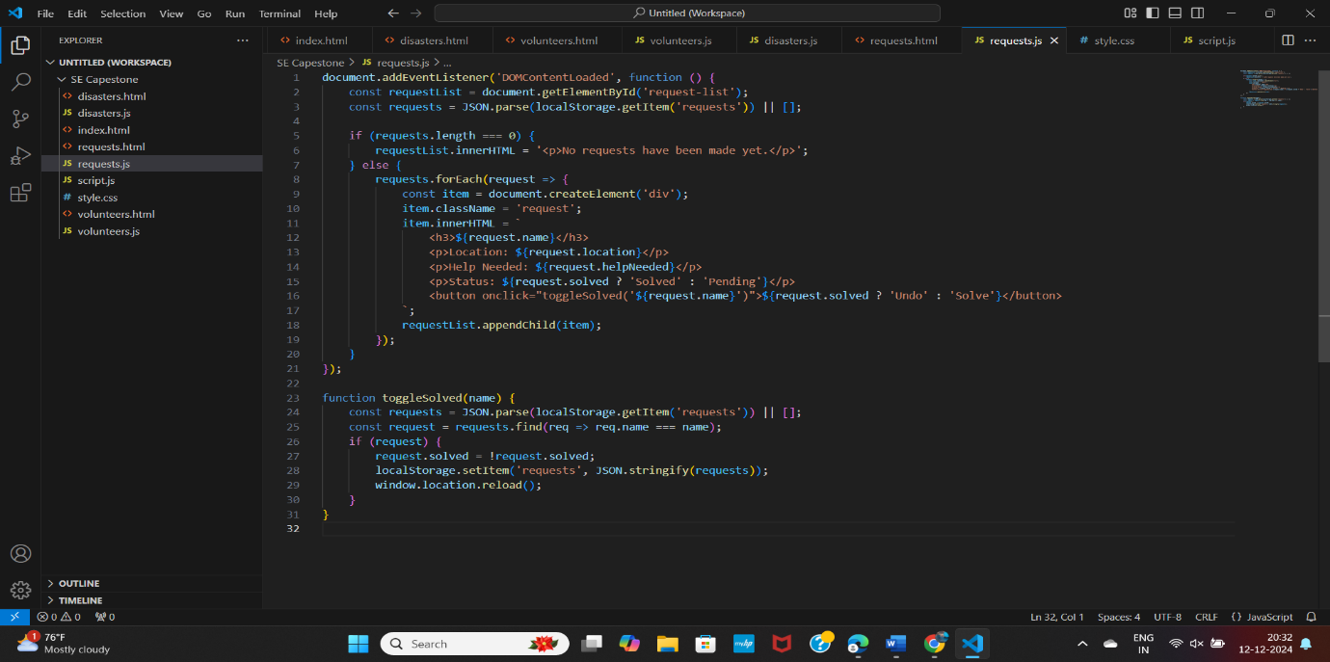

**script.js:**

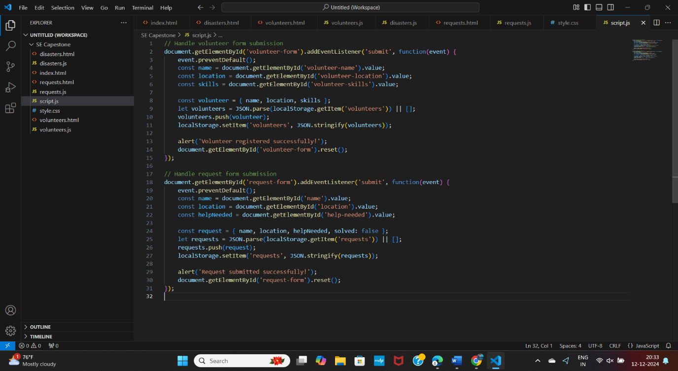

**style.css:**

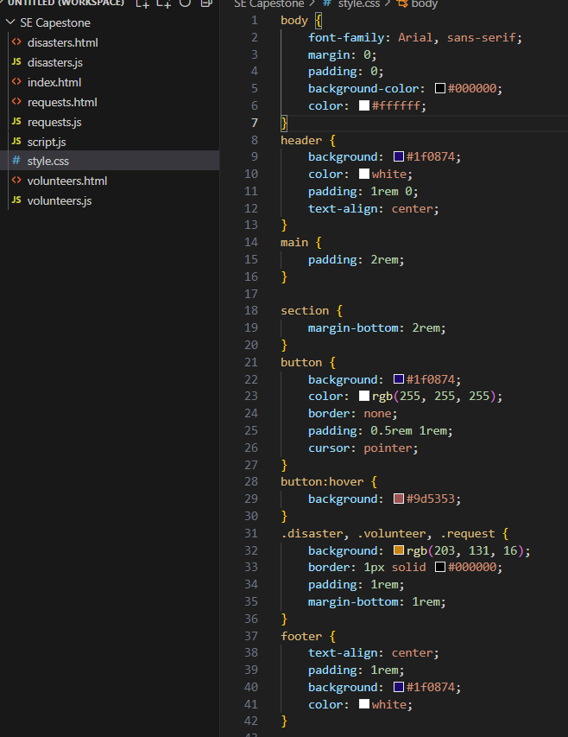

**Development**

The development was carried out in iterative sprints, each focusing on specific features:

**Sprint 1**: Developed the homepage with navigation links and basic forms for volunteer registration and help requests.

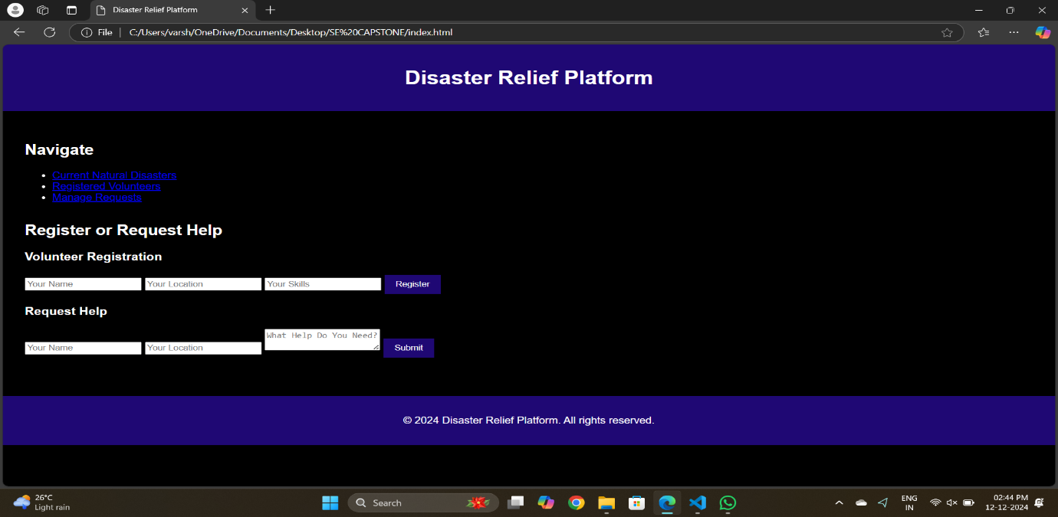

**Volunteer Registration:**

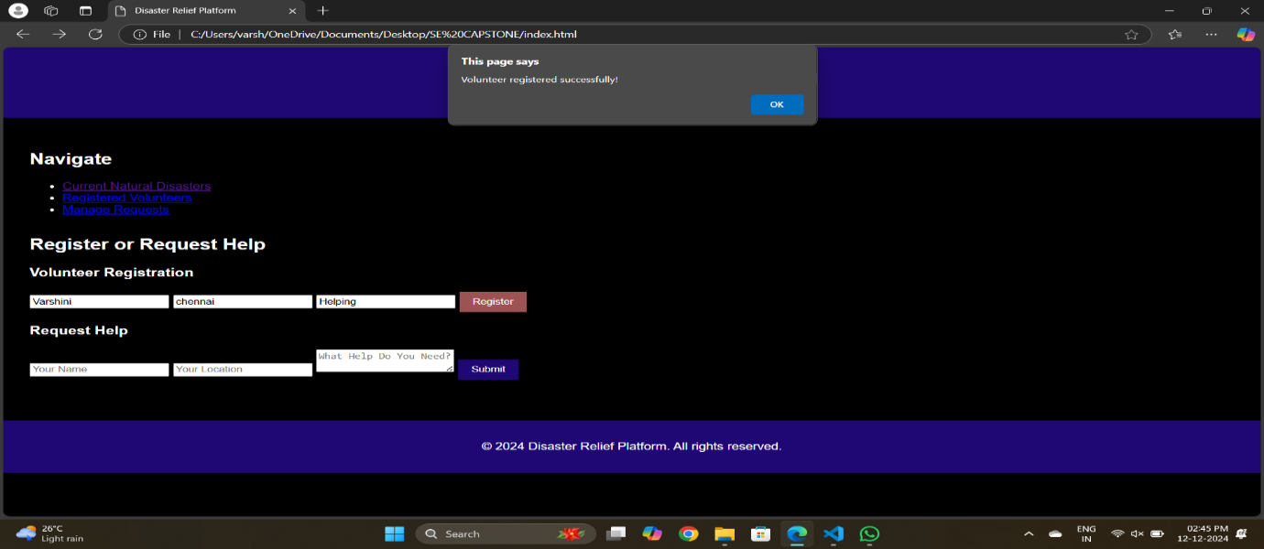

**Requesting Help:**

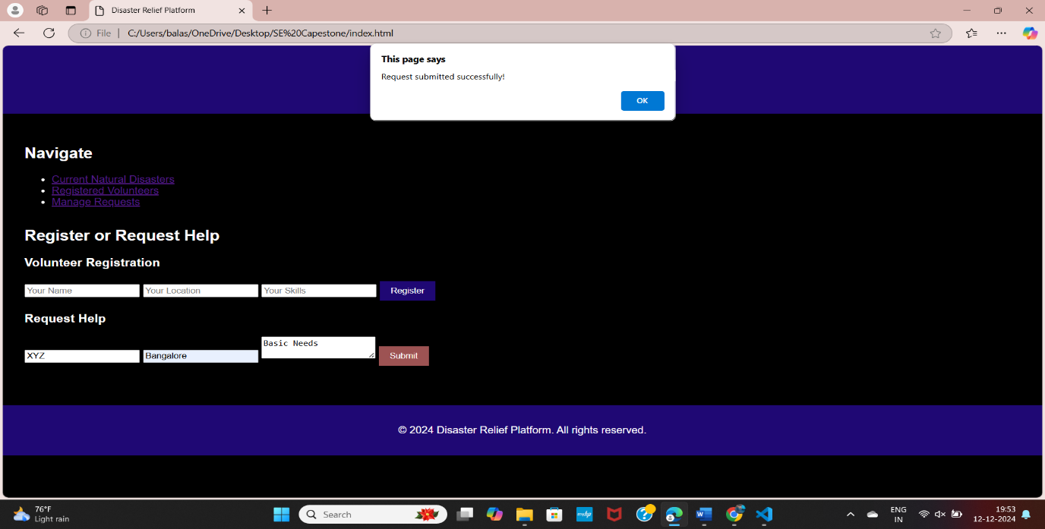

**Sprint 2**: Implemented pages to display current disasters, volunteer lists, and manage requests dynamically.

**current disasters:**

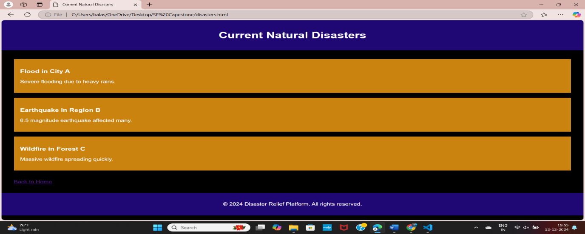

**Volunteer lists:**

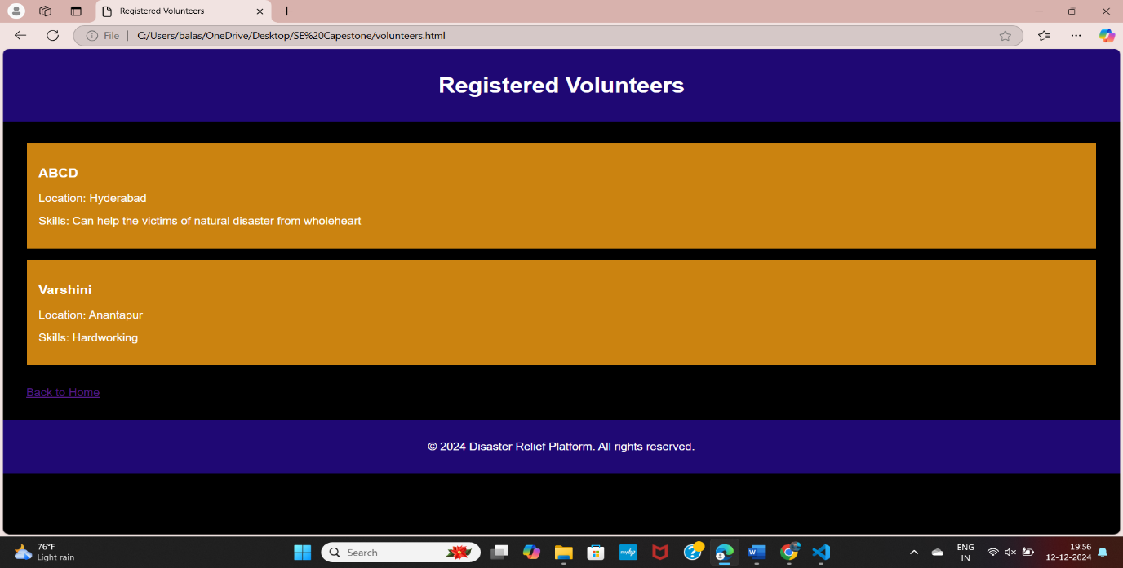

**Manage Requests:**

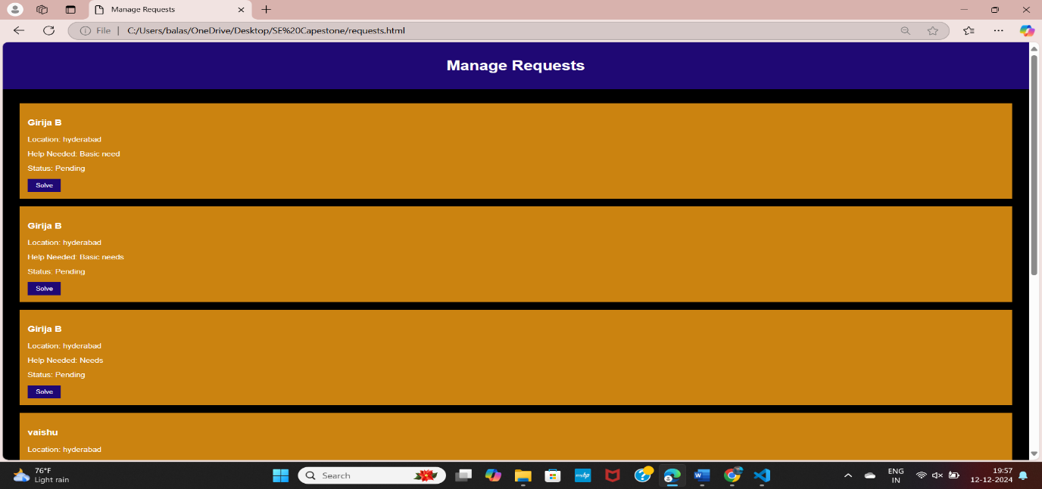**Sprint 3**: Integrated localStorage for storing and retrieving data entered through the forms.

**Sprint 4**: Added features for marking requests as solved and updating volunteer details.

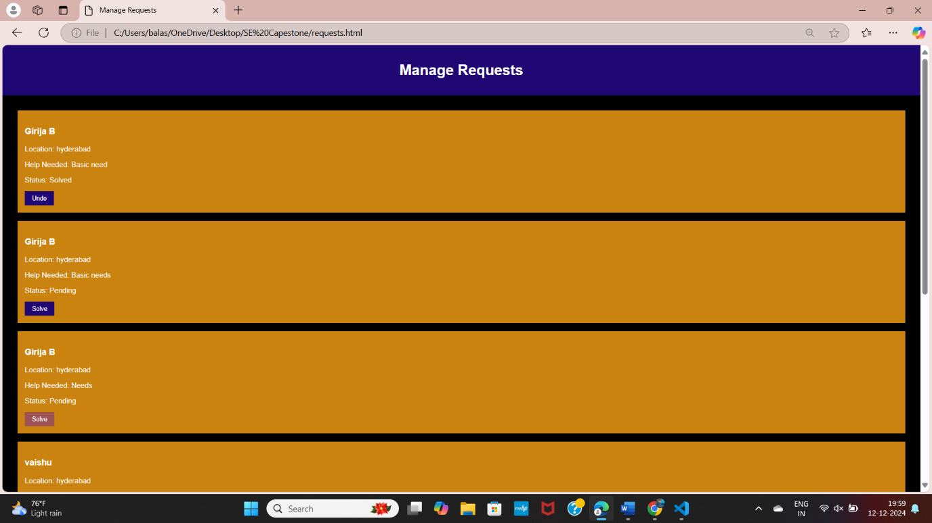**Sprint 5**: Enhanced the user experience with a disaster-themed background and responsive design using CSS.

**Testing and Validation**

* Conducted unit testing to verify individual features, such as form validation, data storage, and retrieval.
* Performed integration testing to ensure seamless navigation and data flow between pages.
* Collected feedback from test users to identify and fix usability issues.

**Deployment**

* Deployed the platform on a local server for demonstration purposes, ensuring compatibility across major web browsers.
* Prepared comprehensive documentation to guide users on utilizing the platform effectively.

**Maintenance**

* Planned periodic updates based on user feedback to enhance features and fix bugs.
* Monitored the platform’s performance to ensure reliability during disaster events.

By following the Scrum methodology, the project maintained a user-centered focus, delivering a functional and effective platform for disaster relief.

**Advantages & Applications:**

**Advantages**

1. Centralized platform for victims, volunteers, and donors to collaborate.
2. Provides real-time disaster updates.
3. Simplifies resource allocation and request management.
4. Accessible on any device with internet access.
5. Lightweight, efficient, and easy to use.
6. Scalable with potential for advanced features.
7. Promotes community engagement and mutual support.

**Applications**

1. Disaster management and emergency response.
2. Coordination tool for NGOs and charities.
3. Community-driven support efforts.
4. Educational and training purposes in disaster response.
5. Resource management for governments and local authorities.

**Conclusion:**

The Crowdsourced Disaster Relief Platform provides an effective solution for bridging the gap between disaster victims, volunteers, and donors. By offering a centralized, web-based system, it ensures real-time updates, efficient resource allocation, and seamless communication during critical times.